

# Title: Basic RC Build

Singh Satish

# Intro

In this document you will find how a basic RC car is put together and how you can choose the best combination of components for your own wishes.

# Information & conclusion

# Basic RC car components

A basic RC car consists of a couple of components:

1. Receiver : gets the radio waves from the controller and outputs those to the IC
2. Servo: to steer the wheels left and right
3. Electronic Speed Controller(esc): takes 2 signals to power the motor.
4. Motor: gives power to the wheels

# Motor

Everything comes down to the motor which is basically the most critical component of the car.  
There are two types of motors you can have.

1. Electric motors: Brushless or brushed
2. Nitro motors

We will be using electric motors that are brushed because they are cheaper. The brushless motors are used for cars to reduce noise and make them last longer.

Nitro motors are used with some sort of nitro fluid which is expensive and dangerous.

## Working of a motor

Here is how a small electric DC-motor works (with brushes):

The core purpose of the motor is to turn electric energy into mechanical energy in the form of rotation. It relies on the magnetic properties of materials.

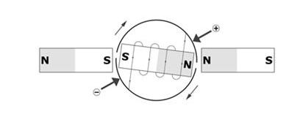Basically if you put an electromagnet in between two magnets and you give current then the magnet will start turning because of the forces working on it.

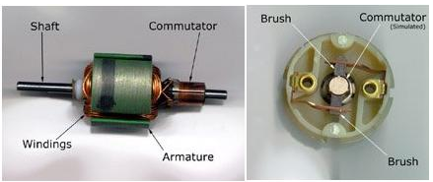To solve the tricky parts we use a commutator.  
This part will make sure the wires wont turn and break but also cause the polarity to switch so the motor wont stop rotating. The commutator is connected via two brushes to the terminal (that is connected to the electromagnet).

## Control of the motor

The motor only has two terminals. You can invert the inputs and the motor will turn the other way.  
We can also disconnect both terminals and then it will just stop getting energy. If you short-circuit both terminals the motor will stop.

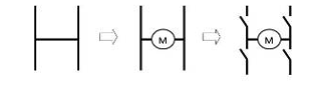To create this we will use the H-bridge formation and in the middle we put the motor.

Now we can control the motor in different ways described.

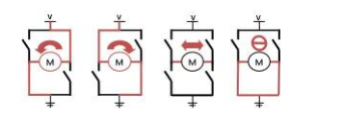

# Servo

This component of the RC car is pure for turning the wheels left or right.

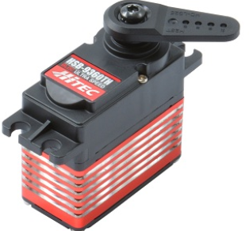

Servo consists of some smaller parts:

1. Controller circuit: will feedback the user input
2. The feedback potentiometer: this is connected to the turning part and is used to calculate the angle of turn
3. The motor: there is a high speed DC-motor inside of the servo which is used to turn the little handle
4. The gearbox: there is a little gearbox that is used to control the rpm.
5. The drive shaft: this will be rotated to the angle the user wishes.

# Electronic speed control

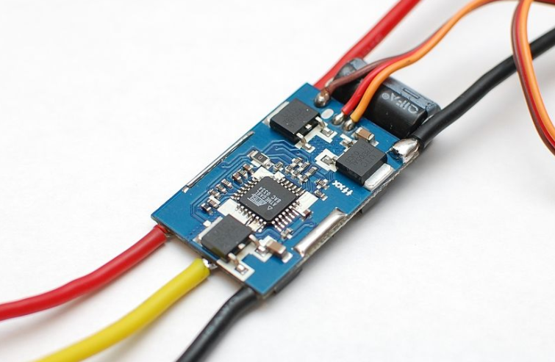This is a small component that is used to regulate the speed of an electric motor.   
To make it easier for ourselves we chose to not play with this component from our microcontroller.

# Referencelist

<http://pcbheaven.com/wikipages/How_RC_Servos_Works/>

<https://community.nxp.com/docs/DOC-1067>

<http://www.rcmodelswiz.co.uk/electronic-speed-controllers-esc/>